Ideation Phase
Define the Problem Statements

Date | 27 February 2026
Team ID | LTVIP2026TMIDS65832
Project Name | Flight Finder
Maximum Marks | 2 Marks

Customer Problem Statement Template:
Create a problem statement to understand your customer's point of view. The Customer Problem Statement template helps you focus on what matters to create experiences people will love.
A well-articulated customer problem statement allows you and your team to find the ideal solution for the challenges your customers face. Throughout the process, you’ll also be able to empathize with your customers, which helps you better understand how they perceive your product or service.
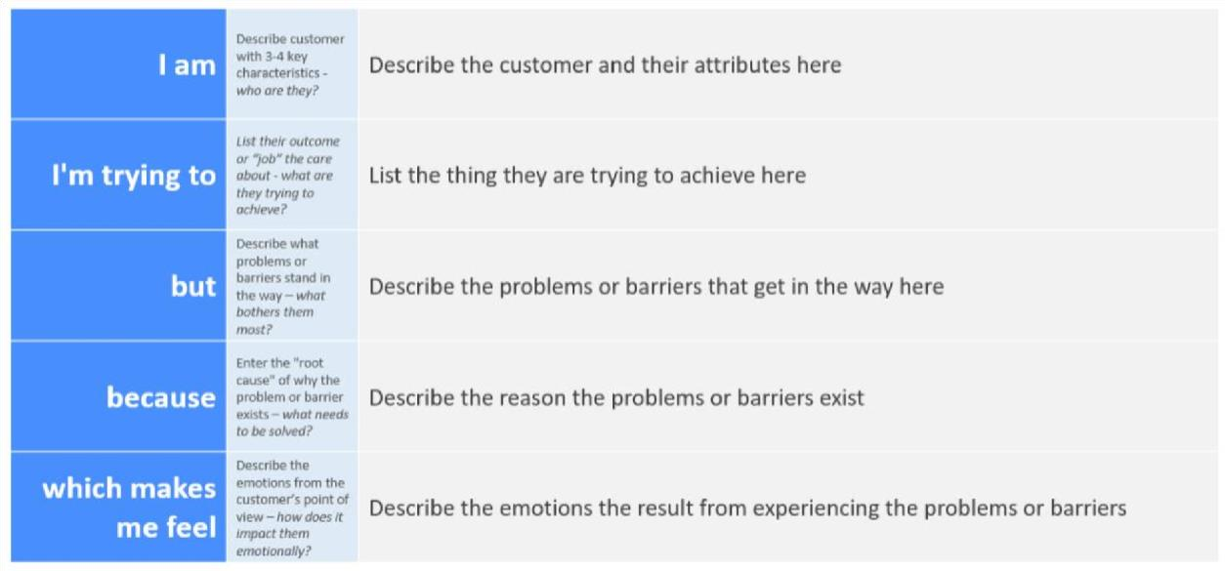
Reference: https://miro.com/templates/customer-problem-statement/ Example:
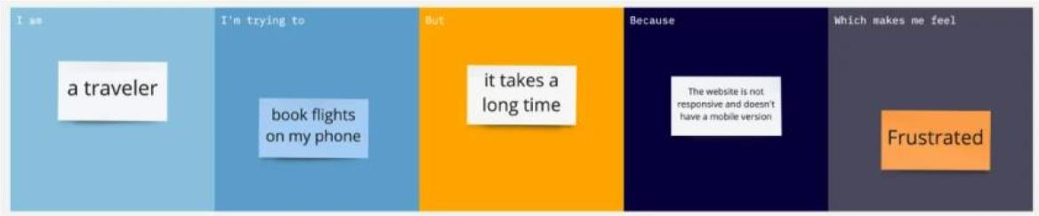

Problem  Statement (PS) | I am  (Customer) | I’m trying to | But | Because | Which makes me feel
PS-1 | a frequent traveller planning personal trips. | Find the cheapest and most convenient flights. | It takes too long to  compare  all options. | There are many airline websites, prices change constantly. | Frustrated and worried I’ll miss a better deal.
PS-2 | a frequent traveller | book flights that fit my meetings | flights are either too early or late | I can’t easily  compare schedules | stressed and worried about missing important events

